**Installing a Router**

Student Version



Huawei Technologies Co., Ltd.

|  |
| --- |
| **Copyright © Huawei Technologies Co., Ltd. 2020. All rights reserved.**  No part of this document may be reproduced or transmitted in any form or by any means without prior written consent of Huawei Technologies Co., Ltd.  **Trademarks and Permissions**  HW_POS_RBG_Vertical-150ppi.png and other Huawei trademarks are trademarks of Huawei Technologies Co., Ltd.  All other trademarks and trade names mentioned in this document are the property of their respective holders.  **Notice**  The purchased products, services and features are stipulated by the contract made between Huawei and the customer. All or part of the products, services and features described in this document may not be within the purchase scope or the usage scope. Unless otherwise specified in the contract, all statements, information, and recommendations in this document are provided "AS IS" without warranties, guarantees or representations of any kind, either express or implied.  The information in this document is subject to change without notice. Every effort has been made in the preparation of this document to ensure accuracy of the contents, but all statements, information, and recommendations in this document do not constitute a warranty of any kind, express or implied. |

|  |  |
| --- | --- |
| Huawei Technologies Co., Ltd. | |
| Address: | Huawei Industrial Base  Bantian, Longgang  Shenzhen 518129  People's Republic of China |
| Website: | <https://e.huawei.com/> |

**Huawei Certification System**

Huawei Certification follows the "platform + ecosystem" development strategy, which is a new collaborative architecture of ICT infrastructure based on "Cloud-Pipe-Terminal". Huawei has set up a complete certification system consisting of three categories: ICT infrastructure certification, platform and service certification, and ICT vertical certification. It is the only certification system that covers all ICT technical fields in the industry. Huawei offers three levels of certification: Huawei Certified ICT Associate (HCIA), Huawei Certified ICT Professional (HCIP), and Huawei Certified ICT Expert (HCIE). Huawei Certification covers all ICT fields and adapts to the industry trend of ICT convergence. With its leading talent development system and certification standards, it is committed to fostering new ICT talent in the digital era, and building a sound ICT talent ecosystem.

Huawei Certified ICT Associate-Datacom (HCIA-Datacom) is designed for Huawei's frontline engineers and anyone who want to understand Huawei's datacom products and technologies. The HCIA-Datacom certification covers routing and switching principles, basic WLAN principles, network security basics, network management and O&M basics, SDN and programmability and automation basics.

The Huawei certification system introduces the industry, fosters innovation, and imparts cutting-edge datacom knowledge.



# Installing a Router

## Background

As a type of core network devices, routers are responsible for data exchange and transmission at the network layer in the TCP/IP protocol stack. This exercise describes how to install an AR6140-16G4XG. Figure 1-1 shows its appearance. Upon completion of this course, you will be able to understand the router's hardware structure and know how to install the router.

Appearance of the AR6140-16G4XG

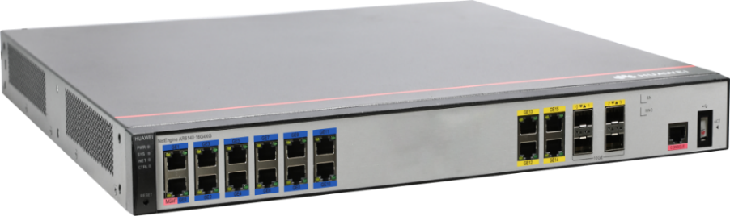

## Objectives

Upon completion of this exercise, you will be able to:

* Get familiar with the router.
* Understand the router's hardware structure.
* Know how to install the router.
* Understand the router installation precautions.

## Planning

This exercise aims to introduce the router and describe the router installation procedure, which lay a foundation for onsite O&M.

Prepare for the installation. Learn about safety precautions, check whether the installation environment and conditions meet the requirements, and prepare the installation tools.

Install the router in a cabinet.

Install cards in uncombined and combined slots.

Connect the ground cable, console cable, Ethernet cable, optical module, optical fiber, and AC power cable to the router.

Power on the router and check whether the router runs normally.

After the installation is complete, check whether the installation meets the requirements according to the installation checklist.

----End

## Implementation

Prepare for the installation.

Carefully read safety precautions.

To ensure human and router safety during the router installation, operation, and maintenance, follow all safety precautions indicated by symbols on the router and those provided in the router's product documentation.

Check the installation environment.

Before installing the router, ensure that the installation environment meets the router's operation requirements. Table 1-1 lists the installation environment check items.

Installation environment checklist

| Check Item | Requirements |
| --- | --- |
| Heat dissipation | There must be more than 50 mm clearance around the router for heat dissipation.   * Do not install the router near a heat source, for example, a stove or heater. * The installation environment must be well ventilated. * Air vents of the router must not be blocked. |
| Temperature and humidity | * Operating temperature: 0°C to 45°C * Operating relative humidity: 5% to 95%, noncondensing     If the relative humidity exceeds 70%, use dehumidifiers or dehumidifying air conditioners. |
| Damp proofing | The router must operate in an environment free from water and moisture.    Water or moisture may damage circuits of the router.   * When the router is installed indoors, it should be installed in a clean, dry, and well-ventilated site with stable temperature. * The installation environment must be free from water seepage, droplets, and condensation. If the relative humidity is high, use dehumidifiers or dehumidifying air conditioners. * Do not install the router downstream or near a water source such as a sink or laundry room, or in an area with a high humidity. * Do not touch the router with wet hands. |
| Electrostatic discharge (ESD) protection | * The router must be reliably grounded according to grounding requirements: * Wear an ESD wrist strap to prevent ESD damages to the router. * Ensure that one end of the ESD wrist strap is grounded and the other end is in good contact with your wrist. |
| Corrosive gases | The installation environment must be free from acidic, alkaline, or corrosive gases. |
| Surge protection | * Signal cables should be routed on internal walls. Do not route signal cables overhead outdoors. * Signal cables should be kept away from power cables and lead-out cables of surge protectors. |
| Electromagnetic environment requirements | The electromagnetic environment requirements must be met. |

Check the cabinet.

Before installing the router into a cabinet, check whether the cabinet meets the installation requirements listed in Table 1-2.

Cabinet checklist

| Check Item | Requirements |
| --- | --- |
| Width | Use a standard 19-inch cabinet. |
| Installation space | There must be at least 3 U of vertical height in the cabinet, and the depth of the cabinet must be at least 600 mm. |
| Grounding | The cabinet must have a reliable ground point for grounding of the router. |
| Heat dissipation | * Sufficient space must be reserved around the cabinet. * If a closed cabinet is used, it must be well ventilated. |
| Mounting rails | If the distance between the front and rear mounting rails does not meet the requirement for router installation, use an L-shaped guide rail for load bearing. |

Check the power supply system.

Table 1-3 lists the requirements for the power supply system.

Power supply system checklist

| Check Item | Requirements |
| --- | --- |
| Preparation | The power supply system must be ready before the installation. |
| Voltage | The operating voltage of the router must be within the normal range as follows:   * Rated input voltage: 100 V AC to 240 V AC, 50 Hz/60 Hz * Maximum input voltage: 90 V AC to 264 V AC, 47 Hz to 63 Hz |
| Power socket and power cable | * If the external power supply system uses an AC power socket, use an AC power cable in compliance with local standards. * If the external power supply system uses a DC power distribution box, use a DC power cable. * The router has its own power cable delivered as an accessory. The power cable can only be used on the router in the same package and cannot be used on any other device. |

Before installing the router, prepare the following installation tools: measuring tape, ESD wrist strap, utility knife, flat-head screwdriver, Phillips screwdriver, marker, diagonal pliers, multimeter, claw hammer, and hammer drill.

Install the router.

Ensure that the following prerequisites are met before the installation:

The cabinet has been well fixed.

The router installation position in the cabinet has been determined and arranged properly.

The router to be installed has been placed near the cabinet for convenient movement.

Prepare the following tools and accessories: Phillips screwdriver, flat-head screwdriver, floating nuts, mounting brackets, guide rails, M4 screws, and M6 screws.

Procedure:

Use a Phillips screwdriver to fix the mounting brackets to both sides of the router with M4 screws. Fix the front mounting brackets on both sides of the front panel and the rear mounting brackets on both sides of the rear panel, as shown in Figure 1-2 and Figure 1-3.

Installing the front mounting brackets

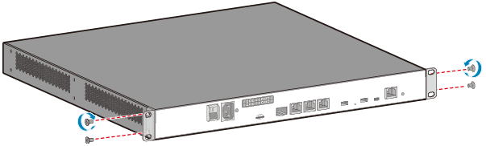

Installing the rear mounting brackets

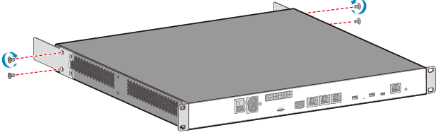

Install two floating nuts on each of the front and rear mounting rails, and leave a mounting hole between the two floating nuts, as shown in Figure 1-4. The distance between three adjacent mounting holes may not be 1 U. Observe the scale marks on the mounting rails when installing floating nuts. The floating nuts on the rear mounting rails must be aligned with those on the front mounting rails. You can use a flat-head screwdriver to install floating nuts.

Installing nuts

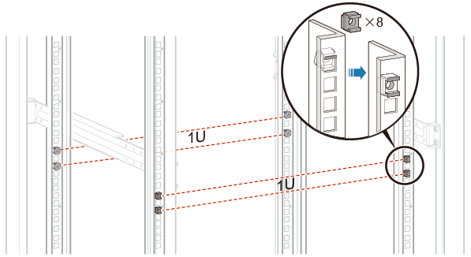

Secure the guide rails on the rear mounting rails of the cabinet, as shown in Figure 1-5.

Securing the guide rails

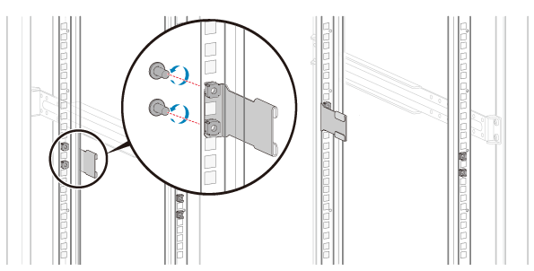

Install the router into the cabinet.

1. Move the router into the cabinet, align the rear mounting brackets with the guide rails, and gently push the router into the cabinet until the front mounting brackets are completely attached to the front mounting rails, as marked by callout **a** in Figure 1-6
2. Use M6 screws to secure the front mounting brackets to the cabinet, as marked by callout **b** in Figure 1-6.

Installing the router into the cabinet

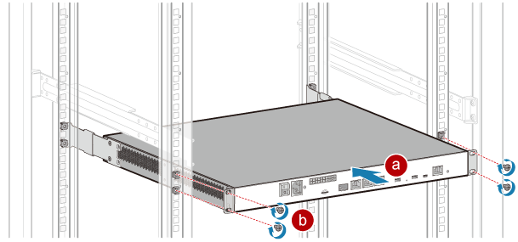

Connect the router.

Connect the ground cable.

Prepare the following tools and accessories: Phillips screwdriver, multimeter, ESD wrist strap, ground cable, and M6 screw.

Procedure:

1. Wear an ESD wrist strap. Ensure that one end of the ESD wrist strap is grounded and the other end is in good contact with your wrist.
2. Connect the ground cable, as shown in Figure 1-9.
3. Use a Phillips screwdriver to remove the M4 screw from the ground point on the rear panel of the router. Keep the M4 screw in an appropriate place for later use.
4. Align the M4 lug of the ground cable with the tapped hole on the ground terminal, and then secure the ground cable with the M4 screw. Tighten the M4 screw with a torque of 1.4 N•m.
5. Connect the M6 lug of the ground cable to the ground point on the cabinet where the router is installed. Tighten the M6 screw with a torque of 4.8 N•m.

Connecting the ground cable

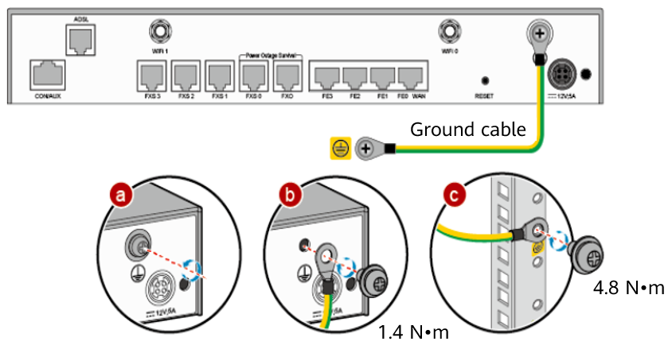

Perform the following checks after connecting the ground cable:

1. Verify that the ground cable is securely connected to the ground points at both ends.
2. Use a multimeter to measure the resistance between the ground points at both ends of the ground cable. The resistance must be smaller than 5 ohms.

Connect the console cable.

Prepare the console cable.

Procedure:

Connect the console cable, as shown in Figure 1-10.

1. Connect the RJ45 connector of the console cable to the CON/AUX port (RJ45) of the router.
2. Connect the DB9 connector at the other end of the console cable to the serial port (COM) of a management PC.

Connecting the console cable

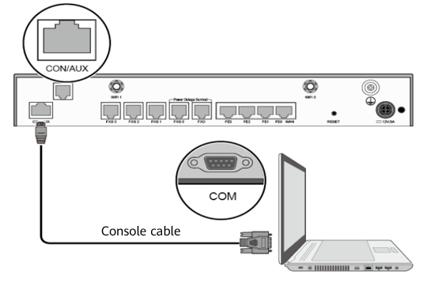

The Windows 7 OS does not provide the HyperTerminal. You can download free HyperTerminal software, such as PuTTY, from the Internet. The following uses the PuTTY as an example.

1. Download the PuTTY software to the PC and double-click it to run the software.
2. Select **Session** and set **Connection type** to **Serial**.
3. Set the serial port parameters, as shown in Figure 1-11.

Setting PuTTY parameters

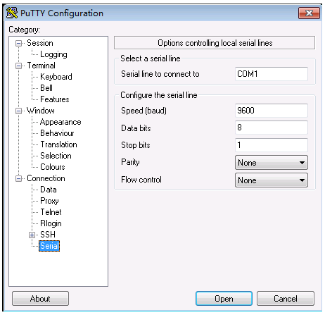

1. Click **Open**. The router copyright statement is displayed. Enter the default user name and password as prompted to log in to the CLI of the router.

Connect Ethernet cables.

Prepare the following tools and accessories: diagonal pliers, cable ties, marker, Ethernet cables, and cable labels.

Procedure:

1. Select Ethernet cables of appropriate quantity and lengths based on the number of ports and measured cabling distances.
2. Attach temporary labels to both ends of each Ethernet cable and write numbers on the labels to identify the Ethernet cables.
3. Lead an Ethernet cable into the cabinet from the top cable inlet (for overhead cabling) or bottom cable inlet (for on-ground cabling), and route the cable from one side of the cabinet.
4. Connect one end of each Ethernet cable to the Ethernet port on the router and the other end to the Ethernet port on the peer device, as shown in Figure 1-12.

Connecting an Ethernet cable

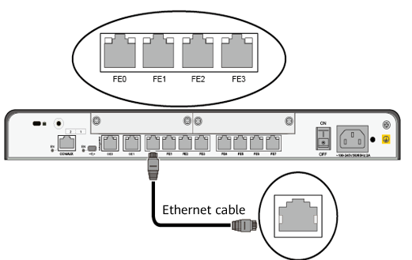

1. Arrange the Ethernet cables to make them parallel, and then bundle them with cable ties. Use diagonal pliers to cut off redundant cable ties.
2. Remove the temporary labels from the Ethernet cables, and then attach formal labels 2 cm away from the connectors at both ends.

Perform the following checks after connecting Ethernet cables:

1. Verify that labels are correctly filled and securely attached to the Ethernet cables, with texts facing the same direction.
2. Verify that Ethernet cables and connectors are complete, intact, and correctly and tightly connected.

Connect optical modules and optical fibers.

Before connecting optical modules and optical fibers, carefully read the safety precautions for laser operations.

Procedure:

1. Gently push an optical module into an optical port smoothly until you hear a click sound. If the optical module cannot be completely inserted into the optical port, do not force it into the port. Turn the optical module 180 degrees over and try again.
2. Remove the dust plug from the optical module.
3. Before connecting an optical fiber, attach temporary labels on both ends of the optical fiber to identify them.
4. Remove the dust cap from the optical fiber connector, insert one end of the optical fiber into the optical module, and connect the other end of the optical fiber to the peer device, as shown in Figure 1-13. Connect the receive and transmit ends of the optical fiber connector according to the identifiers on the receive and transmit bores of the optical module. Do not connect the two ends reversely.

Connecting optical fibers

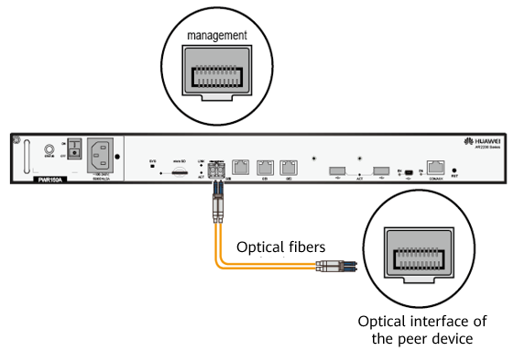

1. Arrange the optical fibers to make them parallel and bundle them with fiber binding tape at an interval of 150 mm to 300 mm.
2. Replace all temporary labels on the optical fibers with formal labels.

Connect an AC power cable.

Prepare the following tools and accessories: ESD wrist strap, AC power cable, and power cable locking latch.

Procedure:

1. Verify that the router has been reliably grounded.
2. Verify that the power switch of the router has been turned off.
3. Wear an ESD wrist strap. Ensure that one end of the ESD wrist strap is grounded and the other end is in good contact with your wrist.
4. Connect the AC power cable. Connect one end of the AC power cable to the power socket on the router and the other end to an AC power socket.
5. Connect a power cable locking latch, as shown in Figure 1-14.
6. Insert power cable locking latch into the jack on the rear panel of the router.
7. Adjust the power cable locking latch to a proper position.
8. Lock the AC power cable with the power cable locking latch.

Connecting a power cable locking latch

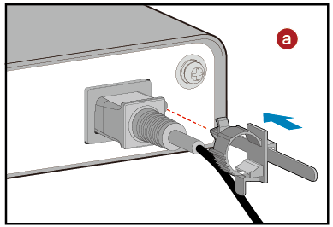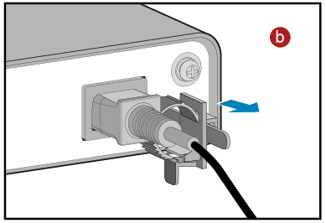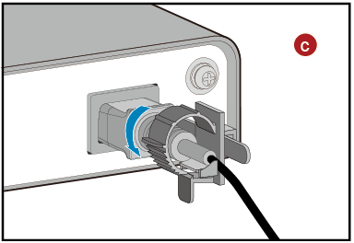

Perform the following checks after connecting the power cable:

1. Verify that the power cable is securely connected to the power socket on the router.
2. If multiple routers are installed, attach labels to both ends of each power cable and write numbers on the labels to identify them.

Install cards.

All cards are hot swappable. Vacant slots in the router must be covered with filler panels. When installing a card in a slot, slowly insert it into the slot. If you feel resistance or find the card inclined, pull the card out and push it into the slot again. Do not push the card forcibly; otherwise, the connectors on the card and backplane may be damaged. A card can only be installed in a router that supports it.

Prepare an ESD wrist strap and a Phillips screwdriver.

Procedure:

Wear an ESD wrist strap. Ensure that one end of the ESD wrist strap is grounded and the other end is in good contact with your wrist.

Loosen the captive screws on the filler panel and remove the filler panel.

Perform the following steps to install a card in an uncombined or a combined slot:

1. Install a card in an uncombined slot.

The following describes how to install a SIC card in a SIC slot, as shown in Figure 1-7. The procedure for installing other cards in uncombined slots is similar.

1. Rotate the ejector lever outward and slide the card into the slot along the guide rails, until the card panel is closely attached to the router panel.
2. Rotate the ejector lever inward until the card is completely seated in the slot, and then tighten the captive screws on both sides of the card.

Installing a card in an uncombined slot.

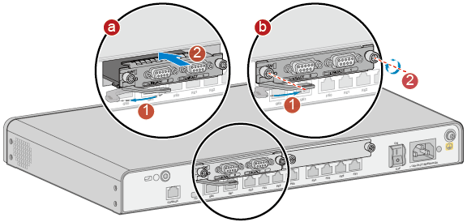

1. Install a card in a combined slot.

Slots of the router can be combined into a larger slot. The following describes how to install a WSIC card in a WSIC slot combined by two SIC slots, as shown in Figure 1-8. The procedure for installing other cards in combined slots is similar.

1. Loosen the captive screw on the guide rail between the two SIC slots.
2. Remove the guide rail to combine the two SIC slots into a WSIC slot.
3. Slide the WSIC card into the WSIC slot horizontally along the guide rails until the card is completely seated in the slot. Rotate the ejector levers inward to lock the card in the slot, and then tighten the captive screws on both sides.

Installing a card in a combined slot

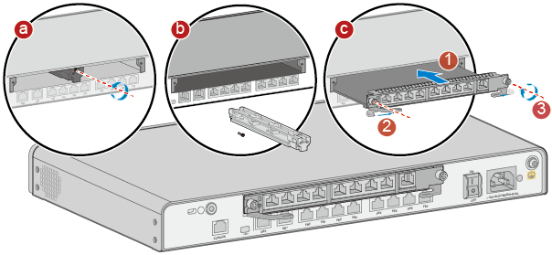

Power on the router.

Before powering on the router, observe and ensure the following:

The power adapter is correctly connected.

The input voltage is in the range from 90 V AC to 264 V AC.

Procedure:

Turn on the power switch of the external power supply system, and then turn on the power switch on the router to start the router.

After the router starts, observe the indicators on the front panel of the router to check whether the router is running normally.

If the SYS indicator is blinking green slowly, the router is running properly.

Perform post-installation checks.

Table 1-4 lists the items to be checked after the router installation.

Post-installation checklist

| No. | Check Item | Check Method |
| --- | --- | --- |
| 1 | The router's installation position meets the requirement in the associated engineering design document. | Observe |
| 2 | The surfaces of the router are clean and smooth, free from fingerprints, stains, and scratches. | Observe |
| 3 | Components are correctly installed in the cabinet. No component is loose or damaged. | Observe |
| 4 | All screws are correctly tightened. | Observe |
| 5 | There are no objects on the router. | Observe |
| 6 | At least 50 mm clearance is reserved on the left and right sides of the router for heat dissipation. | Measure |
| 7 | Signal cables are not damaged or broken and have no splices. | Observe |
| 8 | Signal cable connectors are clean, intact, and correctly connected. Wires of each signal cable are securely clamped in the connectors. | Observe |
| 9 | Each signal cable has labels attached at both ends, with clear text facing the same direction. | Observe |
| 10 | The power cable and ground cable are all copper wires, and are not spliced or damaged. | Observe |
| 11 | The power cable and ground cable are routed in compliance with the associated engineering design document and meet the power distribution requirements. | Observe |
| 12 | The power cable and ground cable are reliably connected. The spring washers of ground cable terminals are placed on the flat washer. | Observe |
| 13 | The power cable and ground cable are separated from the signal cables. | Observe |
| 14 | The power cable and ground cable are straightly routed and neatly bundled. Sufficient slack is left at the bent part of the cables. | Observe |
| 15 | Optical fibers routed out of the cabinet are protected. For example, they are routed in a corrugated pipe or trough. | Observe |
| 16 | The bend radius of optical fibers is 20 times larger than their diameter. In most cases, the bend radius is larger than 40 mm. | Measure |
| 17 | Optical fibers are neatly routed and bundled using binding tape with moderate strength. | Observe |
| 18 | No signal cables are routed near the heat vents on the cabinet. | Observe |
| 19 | Cables in the cabinet do not cross each other and cables outside the cabinet are bundled. | Observe |

----End

## Project Result Records

Check the items listed in Table 1-4 and record the check results.

Record the status of indicators on the router after the router is powered on and check whether the router is running properly.

----End